**Project Plan for**

**Daily Water Intake Tracking Mobile App**

Table of Contents

1. INTRODUCTION 1

1.1. Purpose of the Project 1

2. EXECUTIVE SUMMARY OF PROJECT CHARTER 1

2.1. Executive Summary 1

2.2. Assumptions and Constraints 1

2.3. Main Features of the App 2

2.4. Work Breakdown Structure 3

2.5. Deployment Plan 3

3. SCHEDULE MANAGEMENT 3

3.1. Milestones 3

3.2. Project Schedule – Gantt Chart 4

4. COST MANAGEMENT 5

5. QUALITY MANAGEMENT 5

6. RESOURCE MANAGEMENT 5

6.1. Project Team Members 5

6.2. Tools and Software 6

7. COMMUNICATION MANAGEMENT 7

7.1. Communication Matrix 7

8. RISK MANAGEMENT 8

8.2 Risk Assessment 9

8.3. Risk Mitigation Strategies 9

# 1. INTRODUCTION

## 1.1. Purpose of the Project

The purpose of this project plan is to outline the framework and processes to guide the development, deployment, and management of Daily Water Intake Tracking Mobile App. The document defines how the project will be managed including the scope, schedule, cost, quality, risks, and communication. The document is intended to be a reference for all the stakeholders, including the project sponsor, senior leadership, and the project team, ensuring alignment on project goals and progress.

# 2. EXECUTIVE SUMMARY OF PROJECT CHARTER

## 2.1. Executive Summary

The Daily Water Intake Tracking Mobile App is a health-focused mobile application that is designed to help users monitor and track their daily water intake. The app aims to promote better hydration habits by enabling users to log their water consumption, set daily intake goals, receive reminders, and analyze their hydration trends over time. The timeline of development spans approximately six months, with key milestones to track progress and ensure timely delivery. With a focus on user needs and health benefits, this app will help promote healthier living by addressing the often-overlooked issue of hydration.

## 2.2. Assumptions and Constraints

**Assumptions**: Users will have mobile devices capable of running the app (iOS, Android), development tools are readily available, and no significant regulations impact the app.

**Constraints:** The budget limitations and tight deadlines for project completion, such as the timely availability of third-party services (e.g., app store approval) and integration with fitness devices (optional feature).

## 2.3. Main Features of the App

* **Daily Water Intake Logging:** Users can easily log the amount of water they drink throughout the day using simple controls, with options for selecting predefined volumes (glass, bottle) or custom accounts.
* **Personalized Hydration Goals:** The app will calculate daily water intake goals based on user-specific factors such as weight, age, activity level, local climate conditions, providing personalized hydration target.
* **Push Notifications and Reminders:** Users receive automated reminders at regular intervals to stay hydrated, with the ability to customize the frequency and timing of these notifications.
* **Multi-Device Sync and Backup:** Users can sync their data across multiple devices and back up their logs to the cloud, ensuring data is not lost when switching devices,
* **Integration with Health Apps:** The app integrates with popular health platforms (such as Google Fit, Apple Health) to provide holistic view of the user’s health metrics, including activity levels and other wellness data.
* **Offline Mode and Accessibility Options**: For users in areas with limited connectivity, the app provides offline functionality, and also features such as large fonts and voice instructions for better accessibility and personalization.

## 2.4. Work Breakdown Structure

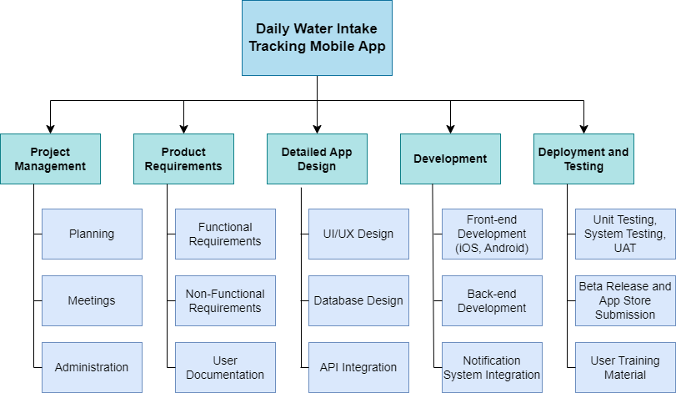

Figure : Project Work Breakdown Structure (WBS)

## 2.5. Deployment Plan

The deployment of the app will involve:

* A phased rollout beginning with beta testing on selected platforms (iOS and Android)
* Gradual public deployment following successful beta feedback and updates
* User documentation and support materials for app onboarding
* Integration with app stores for public release

# 3. SCHEDULE MANAGEMENT

## 3.1. Milestones

|  |  |
| --- | --- |
| Milestones | Estimated Completion Timeframe |
| Project Concept Approval | 1 week after project initiation |
| Requirements Gathering Completion | 3 weeks after project initiation |
| App Design Formulation | 1 month after project initiation |
| App Development | 4 months after project initiation |
| Beta Testing Completed | 5 months after project initiation |
| Final App Deployment to App Stores | 6 months after project initiation |
| User Training and Review | 6.5 months after project initiation |

## 3.2. Project Schedule – Gantt Chart

# 4. COST MANAGEMENT

The cost plan of the project identifies and controls the funds to ensure adherence to budgets. Here, the major categories and project budget allocation include:

|  |  |
| --- | --- |
| Resource/ Milestones | Budget Allocation |
| Planning and Approvals | RS. 20,000 |
| Requirements Gathering | Rs. 80,000 |
| UI/UX Design | Rs. 50,000 |
| App Development | Rs. 1,50,000 |
| Beta Testing and QA | Rs. 50,000 |
| Final Deployment Fees | Rs. 50,000 |
| User Training and Marketing | Rs. 50,000 |
| Maintenance and Support (First 6 months) | Rs. 50,000 |
| Total | **Rs. 5,00,000** |

# 5. QUALITY MANAGEMENT

The quality assurance activities for the app development include:

* Consistent testing for bugs, usability, and security vulnerabilities.
* Code reviews at each development milestone
* User feedbacks during beta testing tor refine user experiences.

# 6. RESOURCE MANAGEMENT

## 6.1. Project Team Members

|  |  |  |
| --- | --- | --- |
| Role | Responsibilities | Required Skills |
| Project Manager | Oversee the project, manage timeline and budgets, and communicate with stakeholders | Project management, communication |
| UI/UX Designer | Design user interfaces, create wireframes and prototypes | Design the app (e.g., Figma), user-centered design principles |
| Mobile App Developer (iOS and Android) | Develop the iOS and Android version of the app, implement features and functionalities | Swift, Java, Android Studio |
| Backend Developer | Develop and maintain server-side logic, and database management | Node.js/ Python, database management (e.g.: MongoDB, MySQL) |
| Quality Assurance (QA) Tester | Conduct testing, identify bugs, ensure app meet requirements | Testing methodologies |
| Technical Writer | Create user documentation, help guides, and training materials | Technical writing, clear communication |

## 6.2. Tools and Software

|  |  |  |
| --- | --- | --- |
| Category | Tools/ Software | Purpose |
| Project Management | Excel, Jira | Tracking progress and managing tasks |
| Design | Figma, Adobe XD | UI/UX design, wireframes, prototypes |
| Development | Xcode, Android Studio, Visual Studio Code, Node.js, Python | Mobile App development |
| Database Management | MongoDB, MySQL, Firebase | Store user data and app information |
| Communication | Zoom, Microsoft Teams | Team communication |
| Marketing | Google Ads, Facebook Ads | Digital marketing and user engagement |
| Analytics | Google Analytics, or Firebase Analytics | Monitoring app usage and user behavior |

# 7. COMMUNICATION MANAGEMENT

## 7.1. Communication Matrix

|  |  |  |  |  |  |  |
| --- | --- | --- | --- | --- | --- | --- |
| Communication | Purpose | Platform | Frequency | Audience | Owner | Deliverable |
| Project Kick-off Meeting | Introduce project scope and goals | Zoom/ Google Meet | Once at project start | All team members, stakeholders | Project manager | Meeting minutes, project charter |
| Weekly Progress Updates | Review progress, discuss challenges | Email | Weekly | Project team | Project manager | Status Report |
| Design Review Meetings | Present UI/UX designs for feedback | Zoom/ Google Meet | Bi-weekly | UI/UX Designer, Developers | UI/UX Designer | Design mockups |
| Development Check-ins and Feedbacks | Discuss development status, issues | Email | Weekly | Developers, Project Manager | Development Team lead | Progress notes |
| Stakeholder Updates | Provide project updates to stakeholders | Email/ Presentation | Monthly | Stakeholders | Project Manager | Update report, presentation |
| Final Project Review | Evaluate project outcomes | Zoom/ Google Meet | Once at project end | All team members, stakeholders | Project manager | Project completion report |

# 8. RISK MANAGEMENT

8.1. Risk Identification

Below is the list of potential risks related with the project:

|  |  |  |
| --- | --- | --- |
| Risk ID | Risk Description | Category |
| R1 | Delays in requirements gathering | Schedule |
| R2 | Technical challenges during app development | Technical |
| R3 | Budget overruns due to unforeseen expenses | Financial |
| R4 | Low user engagement during beta testing | User Acceptance |
| R5 | Regulatory issues regarding health data | Compliance |
| R6 | Changes in project scope of objectives | Scope |
| R7 | Team members turnover affecting project continuity | Human Resource |

## 8.2 Risk Assessment

|  |  |  |  |
| --- | --- | --- | --- |
| Risk ID | Likelihood (1-5) | Impact (1-5) | Risk Score (L*I) |
| R1 | 3 | 4 | 12 |
| R2 | 4 | 4 | 16 |
| R3 | 3 | 5 | 10 |
| R4 | 3 | 4 | 12 |
| R5 | 2 | 5 | 10 |
| R6 | 3 | 4 | 12 |
| R7 | 3 | 3 | 9 |

## 8.3. Risk Mitigation Strategies

For each of the identified risk, the mitigation strategies are proposed as follows:

|  |  |
| --- | --- |
| Risk ID | Mitigation Strategy |
| R1 | Allocate more resources for requirements gathering, schedule buffer time |
| R2 | Conducting regular technical reviews |
| R3 | Monitor budgets closely |
| R4 | Implement user engagement strategies during beta testing |
| R5 | Consulting legal experts to ensure compliance; conducting thorough reviews of regulations |
| R6 | Defining project scope clearly at the beginning; establish a change control process |
| R7 | Fostering a positive team culture; implementing knowledge transfer practices |